**ENGR UH XXXX: Building Information Modeling**

**Demonstration: Digital twin applications for energy management**

**Theory**

The energy audit aims to understand how energy is used inside the building, its user profiles, and the construction and material characteristics that affect its energy consumption. This process focuses on collecting and evaluating many and varied data and information relating to different areas of expertise. Carrying out an effective energy audit consists in collecting a large amount of data of different nature. The correct structure and organization of what is collected will make it possible to understand the energy profile of the building and to choose the most appropriate retrofit scenarios.

In particular, the application of BIM methods and tools in the context of improving the energy performance of existing buildings, although very promising, has to overcome a number of critical issues, such as the identification of necessary information for retrofitting, the collection and proper interpretation of monitored data, the handling of uncertainty and the long time and extensive resources required for the creation of the model of an existing building.

On the other hand, the growing use of BEMS (Building Energy Management Systems) and BACS (Building Automation and Control Systems) in buildings provides a large amount of data on consumption, internal and external environmental conditions and user profiles that can be of great help in energy audit procedures. It also frequently integrates the various building components of sensors that are able to collect data on internal thermal conditions. However, choosing an appropriate method for sensor data visualization is important as it may help users to understand and work with the data faster and easier intuitively.

**Digital twin demonstration:**

This demonstration aims to perform an energy audit based on temperature and humidity on the existing buildings capitalizing on the results in an information model. The experiment follows fig XXX where data is generated in the building space using sensors, then the data is moved from the sensors to the dynamo via IoT platforms. Then the dynamo script migrates the data to Revit model. The result will be displayed via dynamo player.

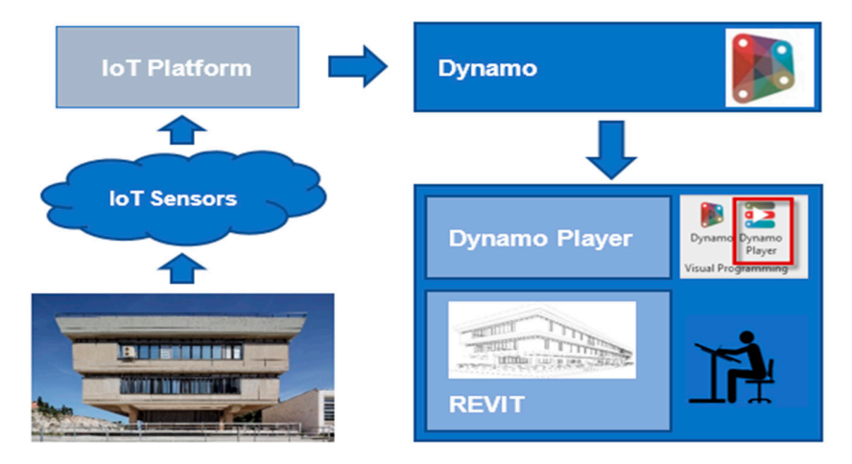

**Procedure:**

1. Develop an as-built model of the sample space (lab space B-29).

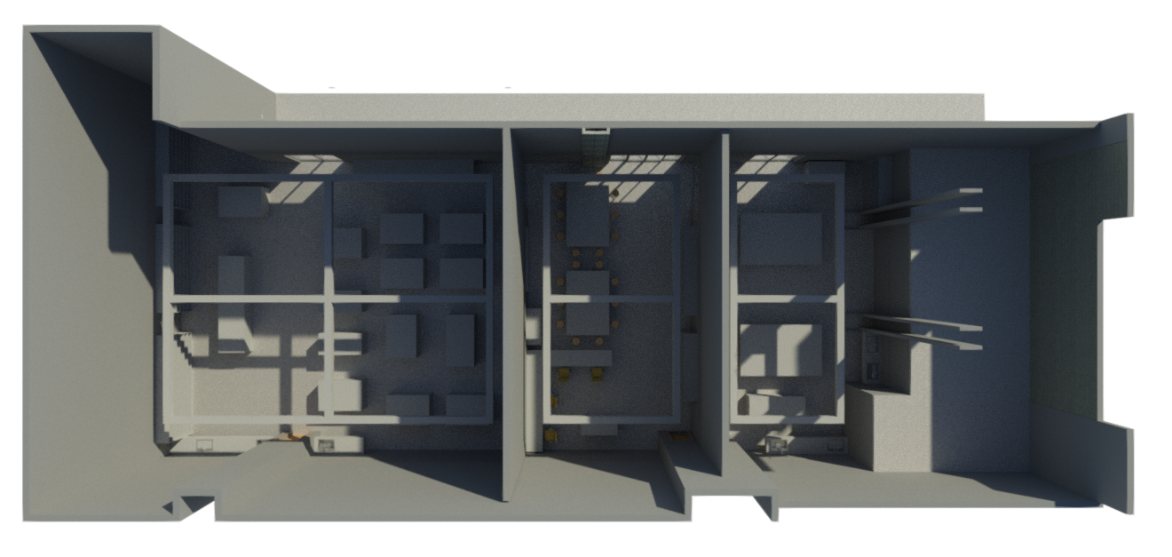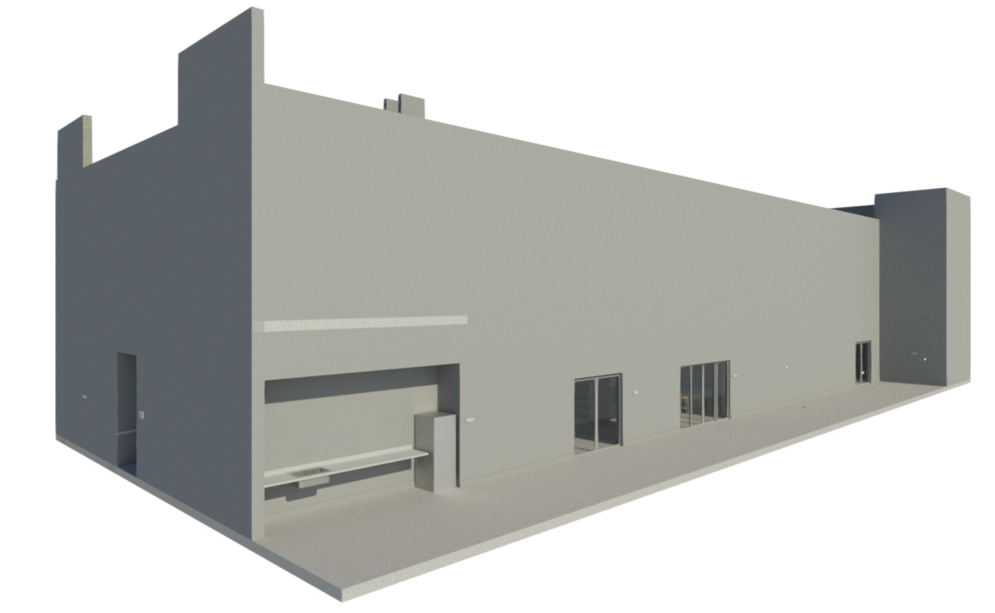

1. Develop Energy model
2. Install sensors and activate IoT Platform. Fig XXXX – the red dots are the approximate sensor installation locations.

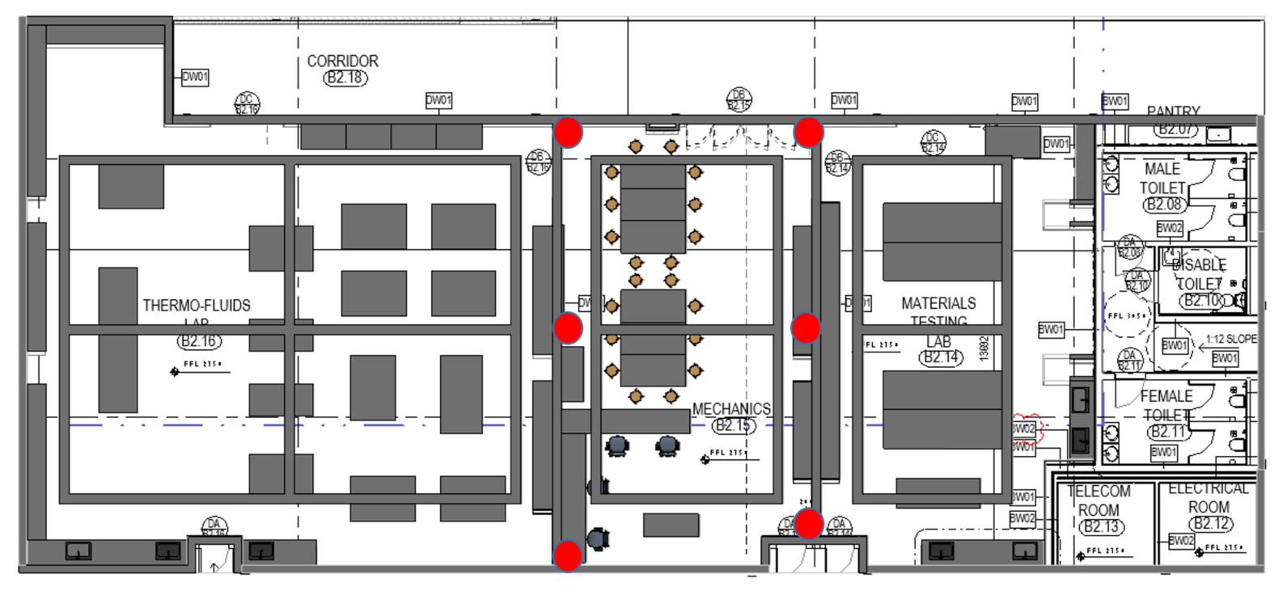

1. The dynamo script converts the data into readable BIM model adjustment

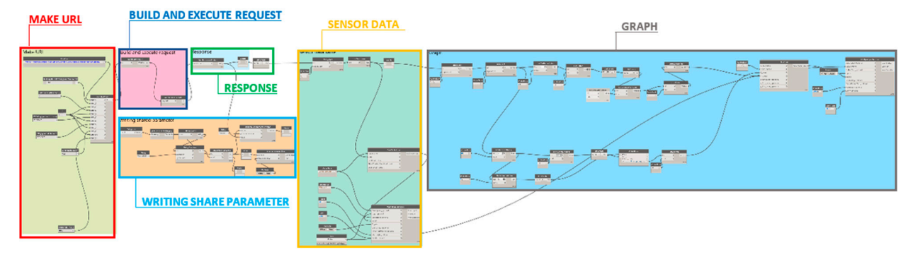

1. Using heaters or adjusting the room HVAC controls, create variations in the room air conditioning to monitor the building's actual change in temperature and humidity.
2. Engineering recommendations could be proposed based on the building's actual vs. planned digital models during the operation phase.

**Required equipment and systems:**

* + 1. 4 – 8 temp and humidity sensors with APIs
    2. Real-time with (5-15min) delay data transfer.
    3. IoT platform to migrate data to Dynamo

**Observations:**

1. Are there differences in the anticipated energy model and the actual performance of the building?
2. Any suggestions on the improvement of the LOD of the energy model to bring the planned and actual data closer
3. Possible sources of error?